# Wireflow

1. Wireflow voluntario

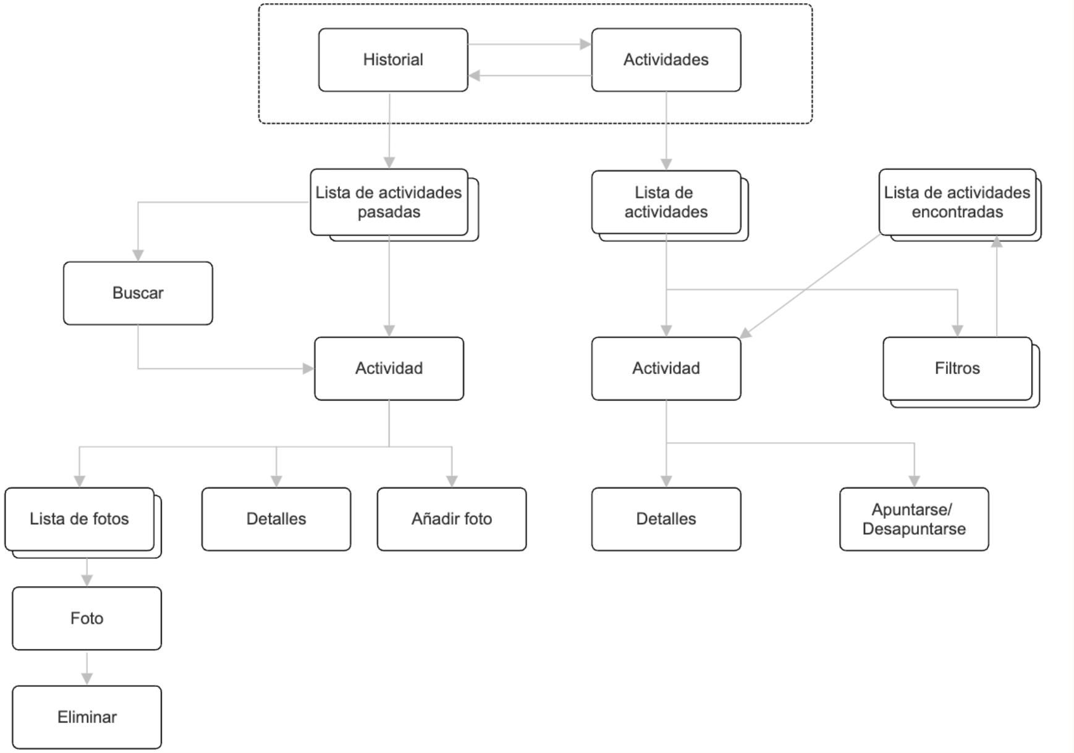

1. Wireflow adulto mayor



1. Wireflow trabajador



1. Wireflow familiar

